# Design Work-Michael

* Done

|  |  |
| --- | --- |
| Mechanic | - Moving - Jump (changes model size to fit through gaps) - Transport between planes - Interaction with objects - Rotate individual planes - Temporary invulnerability |
| Level Design | Screen ClippingScreen Clipping   |  | | --- | | Screen Clipping1.Testing level             2. First level | | |
|
| Character | Screen Clipping- Main character - Name: Raven (tentative) - Late teens/early 20’s - Long black hair, covers 1 eye - Emo/Goth inspired - The Veil: glowing cape/scarf - Positive nihilist (what is going on, this is awesome!)  -The Count o Robed wizard figure o Dark Dumbledore o Guide for Raven, appears/disappears |
| Enemies | Ghouls – attached to floor/wall, set movement (back and forth). Kills Raven on touch. Ghost – Floating in the air, with line of sight to Raven begins following her. If line of sight broken, return to spawn position. Kills Raven on touch. Skeleton – Stationary, fixed points in level. Throw bones in set parabola at set intervals. Bones kill Raven on touch. Green Goo – attached to floors/platforms/walls. Kills Raven on touch. Yellow Goo – progressively slows Raven down. If her speed reaches 0, it kills her. (animation pulls her under) |
| Environment Conception | - The Cathedral - Ancient building with dark magic (castle-like) - Mainly stonework - Different colour palette for each plane - Gardens/ other areas - Visuals for when The Veil can/can’t be used |

* To do

|  |  |
| --- | --- |
| Level Design | Extra potential level |
| Enemies | More enemies with different ability. |
| Game story | We need to finish the game plot in next few weeks |
| Interface | 1.Title 2.Main menu 3.Tip element in game |

# Art Work-Samantha

* Done

|  |  |
| --- | --- |
| Character | Conception & static picture |
| Enemies | -Ghouls: conception & static picture -Dangerous Goo: animate resource |
| Environment | -First version of background -3 kinds of walls -Teleportation area with animate -Locked doors -Key |

* To do

|  |  |
| --- | --- |
| Character | Animation resource for every action: -Running animation -Stationary animation -Jumping animation -Invincible animation -Transport animation -Death animation -Talking animation |
| Enemies | -Ghouls: Walking animation -Ghost: Floating animation -Skeleton: Throwing animation |
| NPC | -The Count |
| Environment | -Platform -Lever -The goal |
| Special effect | -Effect of Raven's move -Effect of environment |
| Interface | -Main title -Button -Dialog box -Tip element |

# Music Work-Stuart

* Done

|  |  |
| --- | --- |
| Music | Title theme |
| Effect Sound | - Raven jumping (woosh) - Raven jumping with the Veil (more like a schloop) - Talking (when text appears, go beep beep boop beep) - Ghoul noise (grunts, mostly) - Picking up key noise |

* To do

|  |  |
| --- | --- |
| Music | 3 themes, 1 for each plane OR 1 theme with 3 variations |
| Effect Sound | - Raven walking - Raven teleporting with The Veil - Raven dying (similar to teleporting) - Ghost noise (whatever noise you think a Ghost makes) - Skeleton noise (bone wizzing through The air, landing) - Acidic goop noise - Floor falling out - Pushing a lever - Giant stone structure rotating - Victory sound |
| Next Stage | Completing the logic structure for Wwise middleware, which will implemented within Unity. Allowing for more efficient workflow going forward.  Musically there will be 3 small separate loops for each “plane,” each with their own style to complement visual aesthetic and characteristics.  I will further compose 6 short transitions to be triggered when player shifts between corresponding “planes”  e.g There will be a separate transition for moving between plane 1 and 2 and another for between plane 1 and 3 and so on.  This interactive audio will highlight the dynamic shift between one plane and another.  Ambient noises such as enemy “grunts” will sound muffled when in the adjacent plane so as to warn player of their proximity, sounding clear when in the same plane as the player.  As more and more visual assets and animations are added to the game, will discuss with team any additional sounds/music required and how they should be triggered in-game. |

# Program Work-Jonny

* Done

|  |  |
| --- | --- |
| Mechanic | Player character created  Jump, Double Jump, Veil Jump.  3 Different Planes, logic for player interacting with different planes.  Plane Transition Animations  Interacting with Portals |
| Sound | Created Script/base logic for applying sounds to objects and background  Implemented sounds for Jump, Double Jump, Veil Jump, Portal and Theme Loop. |
| Environment | TileMaps created for implementing Art Environment Assets.  Created Prototype/Testing level with 3 Planes demonstrating main mechanics. |
| Level Building | Testing level |

* To do

|  |  |
| --- | --- |
| Mechanic | - Rotate individual planes - Temporary invulnerability  - Temporarily Freeze Character when going through portal  - Implement enemies (movement, attacks etc) Ghouls, Ghosts, Skeletons.  - Implement Hazards  Green Goo – attached to floors/platforms/walls. Kills Raven on touch.  Yellow Goo – progressively slows Raven down. If her speed reaches 0, it kills her. (animation pulls her under) |
| Level Building | Build Main 3 Plane Level |
| Interface | -Main menu -Setting -Save data -Game dialog and story telling |

# Others-Yang

* Game content mind map

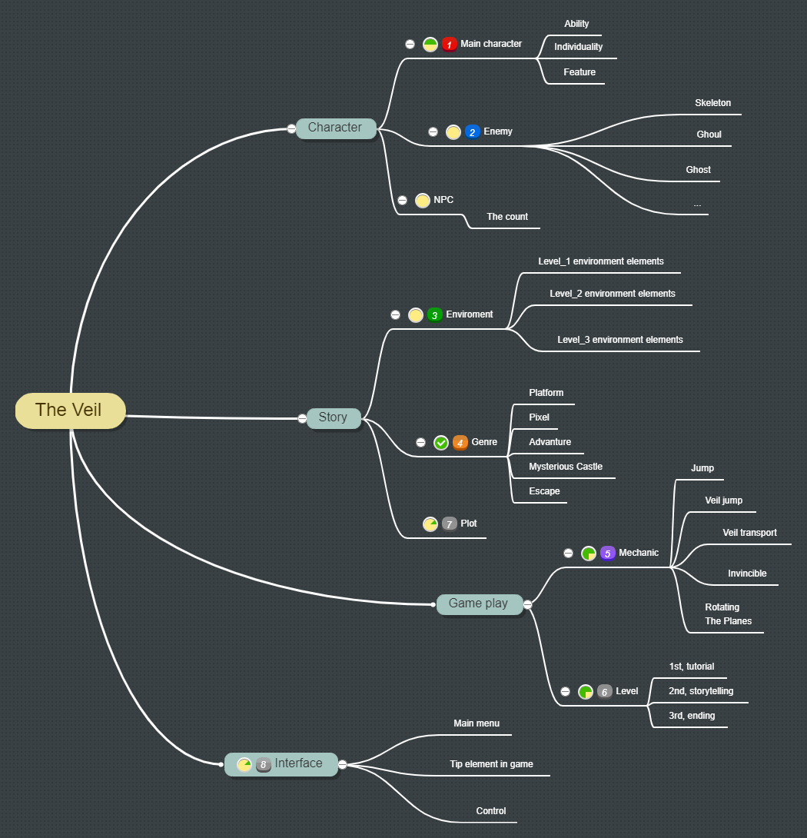

* Work flow

